How To Make Fruit and Cheese Pretzel Kabobs

You’ll Need:

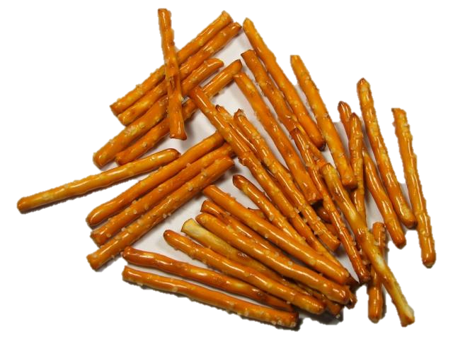
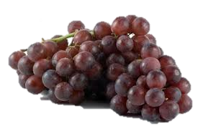
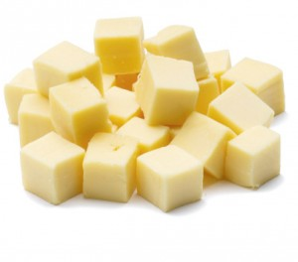
Whole-grain pretzel sticks Reduced-fat cheese cubes
1. Choose 3 cubes of cheese. | 2. Choose 3 pretzel sticks.
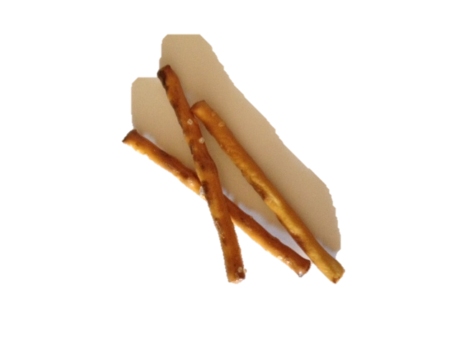
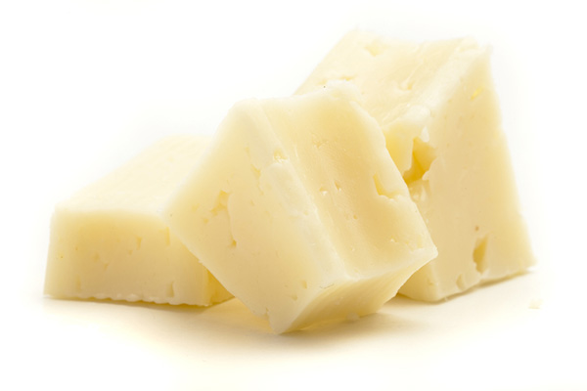
Grapes

